**Greetings,**

Welcome to “Young Lads” Data Structures Wheel of Fortune Final Project. This user manual will consist of a walk through on Game Play and Game Functions.

**This program begins by establishing the player base:**

* User Enters The Name of each (3) Player.
* 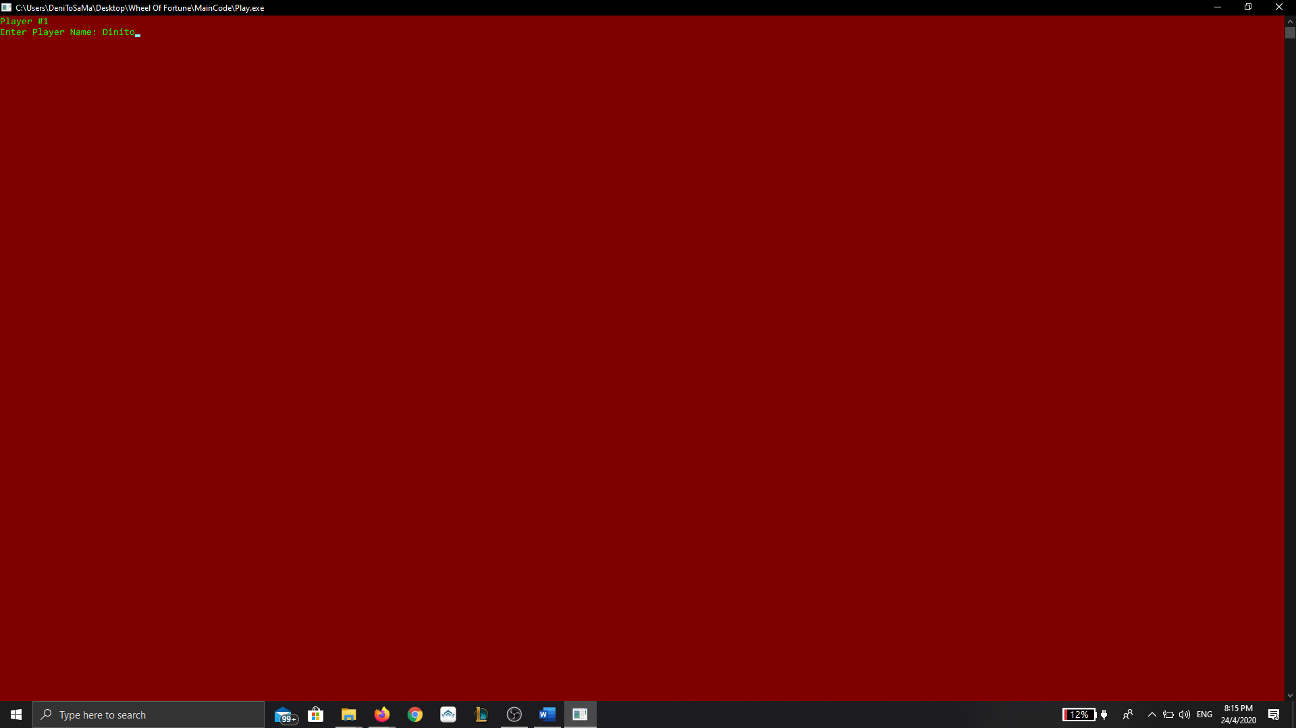
* 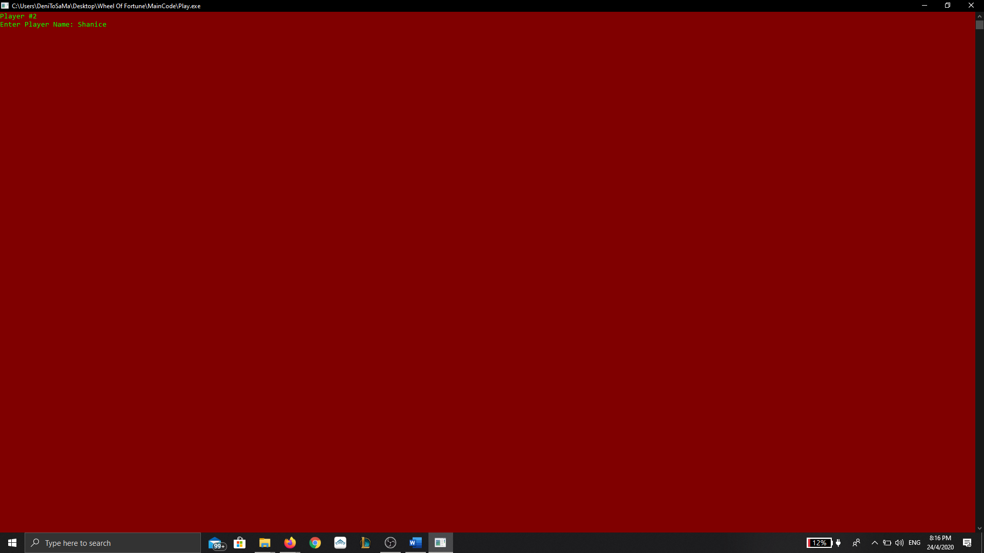
* 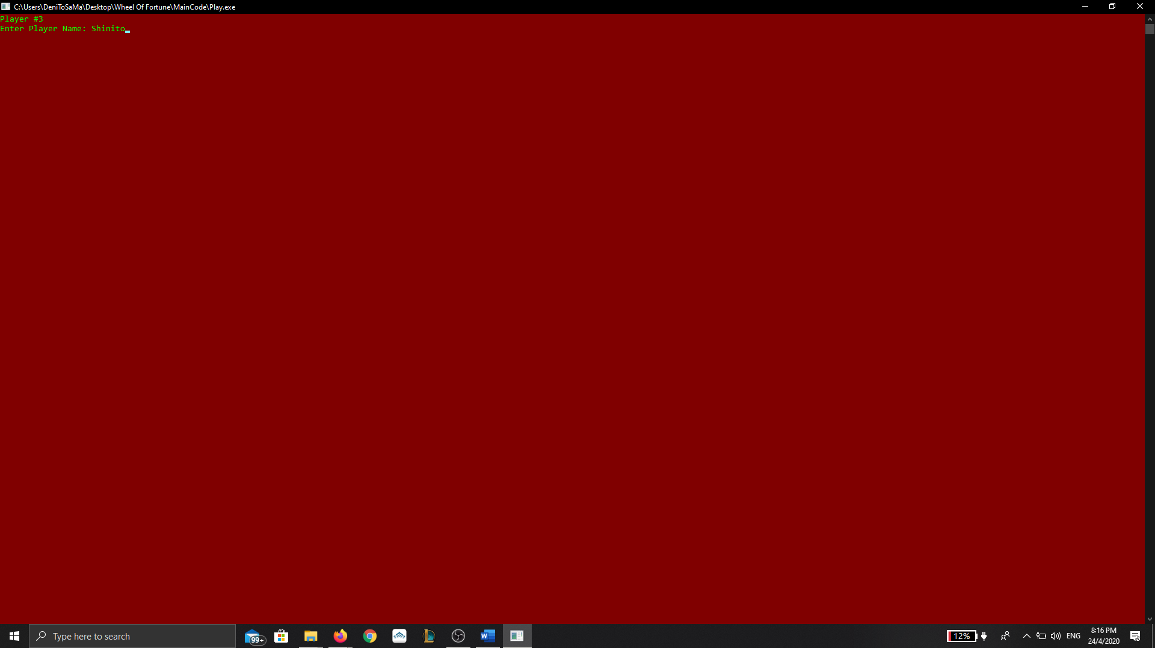
* The Player Base is sorted on a FC-FS (First come, First Serve) bases in a circular fashion.

**File is then open, analysed and read from accordingly:**

* Word/Phrase to be guessed is encrypted then displayed to the screen.
* Player Spins the wheel for a chance to guess the word/phrase.
  + If the player lands on a reward, they will be able to:
    - Guess a letter in order to keep their reward.
    - Guess the entire word.
    - Buy a Vowel
  + If the player lands on a penalty, they will:
    - Lose their turn.
    - Become bankrupt (Which also results in a lost of turn)

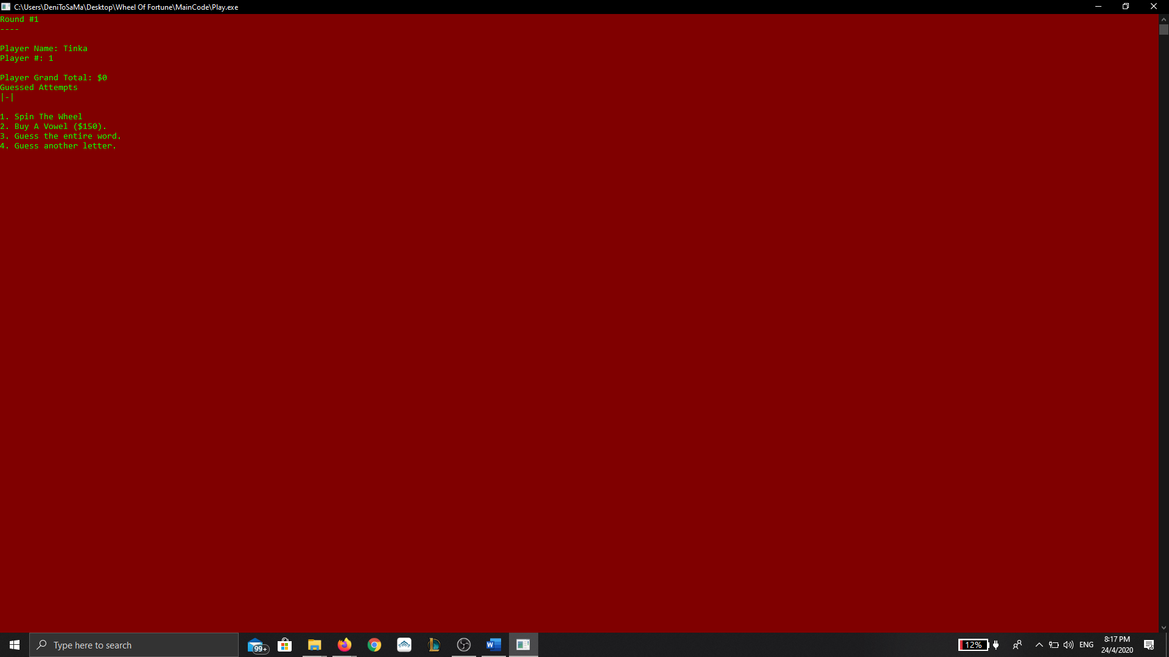

**After each round:**

* The player that made the correct final guess, gets to keep their reward.
* Game advances with a new word/phrase.
* Turn is returned to the player that made the final guess.
* 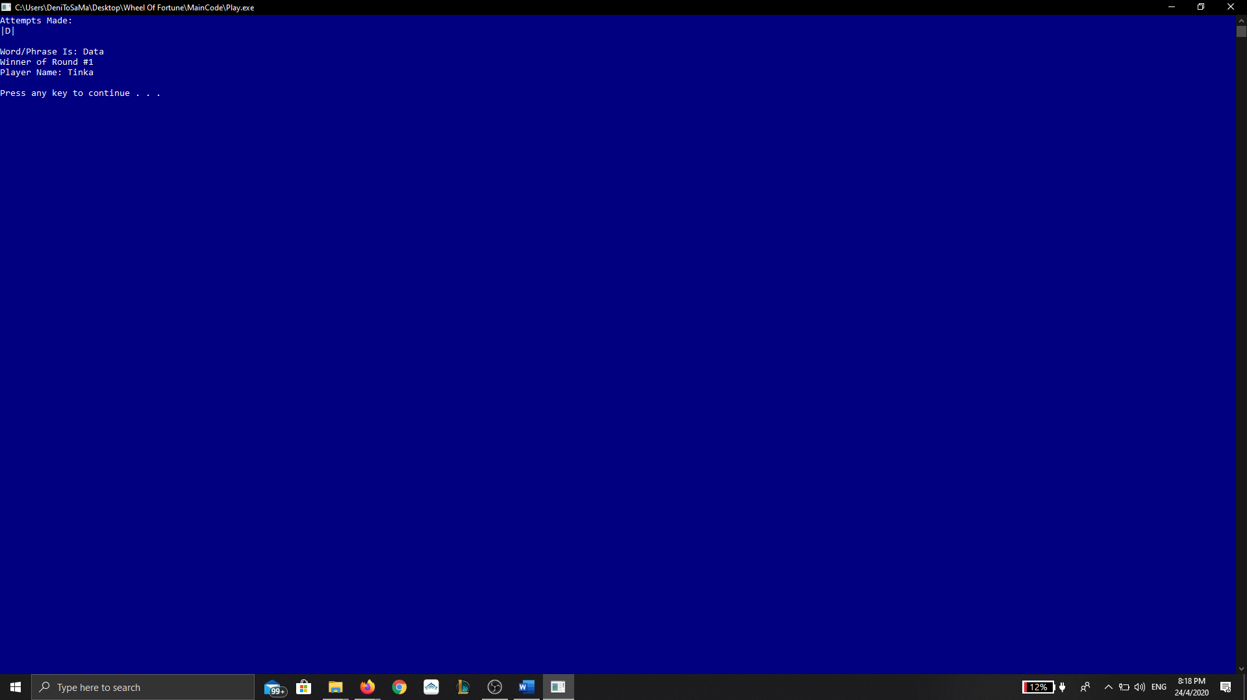

**After the last round:**

* The Player with the highest grand total will be announced as Winner.
* 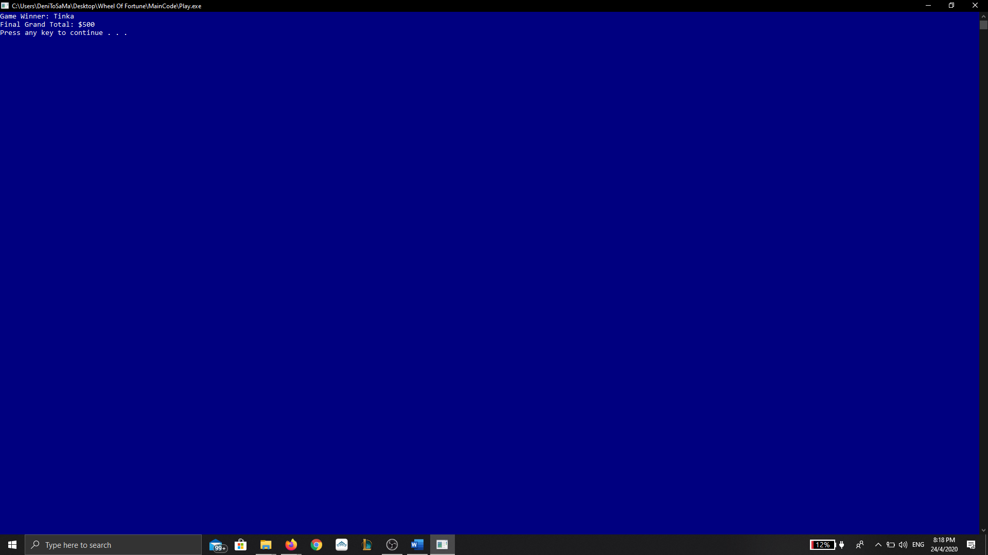
* Players can decide to play again or exit the program.
* 